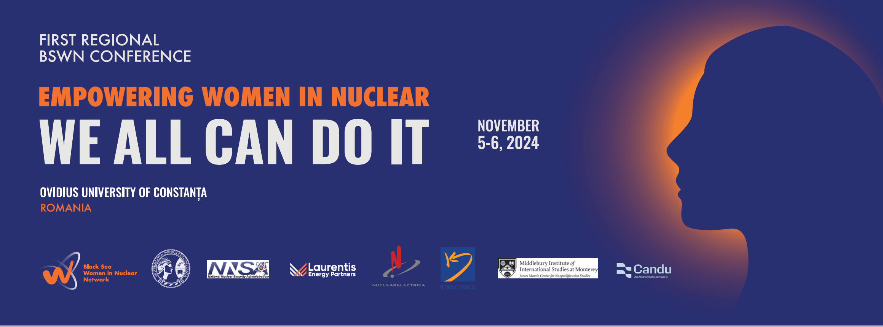
Venue: Ovidius University of Constanța (Aleea Universitatii No. 1, Campus)

TUESDAY, NOVEMBER 5, 2024
08:00-09:00 | Registration of participants
09:00-09:30 | Welcoming Remarks (Senate Hall)
Dr. Cosmin FILIP, Vice-Rector, Ovidius University Constanta
Ms. Nataliia KLOS, BSWN President, World Institute for Nuclear Security (WINS)
Ms. Margarita KALININA-POHL, BSWN Founder, James Martin Center for Nonproliferation Studies, Middlebury Institute of International Studies
Ms. Elena BUGLOVA, Nuclear Security Division Director, International Atomic Energy Agency (IAEA) (recording)
09:30-09:45 | Keynote Address: Mr. Daniel Mihai DUTU, Counsellor, General Directorate for Energy Policy, Ministry of Energy, Romania
09:45-10:45 | Panel I: Preparing the Next Generation of the Workforce for Nuclear Sector (Senate Hall)
Moderator: Ms. Alexandra Loredana MĂCĂNEAȚĂ, Nuclearelectrica

Panelists:
Mr. Romeo URJAN, Nuclearelectrica
Mr. Dumitru CHIRLESAN, Polytechnic University of Bucharest, Romania
Ms. Nataliia SOROKOVA, National Technical University of Ukraine “Igor Sikorsky Kyiv Polytechnic Institute” (KPI)
Dr. Gabriel Lazaro PAVEL, European Nuclear Educational Network

Q&A
10:45-11:15 | Coffee break with an Expert (Featured experts: Dr. Lia CHELIDZE,  Dr. Anastasia BENNETT, Ms. Corina NAY)

11:15-12:15 | Panel II: Women in the Nuclear Sector (Senate Hall)
Moderator: Ms. Madalina STEFANIC, BSWN

Panelists:
Ms. Laura MOSCU THIJOV, Nuclearelectrica, Romania
Ms. Tetiana KOTELINA, National Nuclear Energy Generating Company Energoatom, Ukraine
Ms. Tamar KALADZE, Andronikashvili Institute of Physics, Georgia

Q&A
12:15-13:15 | Panel III Challenges and Opportunities for Women in Nuclear in the Black Sea Region (Senate Hall)
Moderator: Ms. Nataliia KLOS, BSWN, WINS

Panelists:
Ms. Shorena LORTKIPANIDZE, BSWN Vice-President, Civil Council on Defense and Security (CCDS), Georgia
Dr. Senem SENTURK LULE, Istanbul Technical University, Türkiye
Ms. Khrystyna LYLAK, Ukrainian Nuclear Society, Ukraine
Ms Eliana ZATSCHLER, European Women Lawyers Association (EWLA), Belgium

Q&A
13:15-14:15 | Lunch and Networking
14:15-15:30 | Panel IV Best Practices in Empowering Women (Senate Hall)
Moderator: Ms. Loredana POP, Nuclearelectrica, Romania

Panelists:
Ms. Silvia SAVULIAN, Laurentis Energy Partners. Canada
Ms. Anastasia BENNETT, Los Alamos Nuclear Laboratory, USA
Ms. Jasmine AUDA, Ambit Advisory, Jordan
Ms. Sophia BROWN, CRDF Global, USA
Ms. Marina DABETIC, “Vinča” Institute of Nuclear Sciences, National Institute, Serbia

Q&A
15:30-15:45 | Ms. Taylor HART-MCGONIGLE, Department of Energy National Nuclear Security Administration, Nuclear Security Women Initiative
15:45-16:15 | Coffee break with an Expert (Featured Experts: Ms. Florentina GUZU,  Ms. Andreea Elena CIUCANU, Ms. Luisa KENAUSIS)

16:15-17:15 | Parallel Panel V.1 - How to Increase Participation of Young Generation in Nuclear Science and Engineering (Senate Hall)
Moderator: Ms. Florentina GUZU, BSWN Member, Nuclearelectrica, Romania

Panelists:
Ms. Cristina BURUIANA, Nuclearelectrica, Romania
Ms. Fadime Ozge KARAKAS, Istanbul Technical University, Türkiye
Ms. Madalina STEFANIC, BSWN, Romania

Q&A
16:15-17:15 | Parallel Panel V.2 – Voices of Young Generation (Umberto Eco)
Moderators: Ms. Mădălina IONIȚĂ, National Commission for the Control of Nuclear Activities (CNCAN), Romania

Panelists:
Ms. Atiyah HIJRIYANTI, BSWN Mentee, Indonesia
Ms. Viktoriia SKOROPADSKA, BSWN Mentee, Ukraine
Ms. Diana VORONA, BSWN Mentee, United Kingdom
Mr. Illia SNIGUR, BSWN Mentee, Ukraine

Q&A
18:00-20:00 | Reception (Main Hall)
WEDNESDAY, NOVEMBER 6, 2024
09:00-10:30 | Panel VI – New and Emerging Technologies: Opportunities and Challenges for the Nuclear Sector (Senate Hall)
Moderator: Ms. Corina NAY, Candu Energy Inc. - member of AtkinsRealis, Canada

Panelists:
Dr. Concetta FAZIO, Joint Research Centre of the European Commission, Belgium
Mr. Cosmin ANGHEL, Nuclearelectrica, Romania
Ms. Tetiana ZAKREVSKA, Ukrainian Nuclear Society, Ukraine
Ms. Rusham AHMAD, Candu Energy Inc. - member of AtkinsRealis, Canada

Q&A
10:30-11:15 | Coffee break with an Expert (Featured Experts: Ms. Laura Moscu THIJOV,  Ms. Violeta BALAN, Ms. Ketevan ZARIDZE)

11:15-12:15 | Parallel Panel VII.1 - Black Sea Experts NucTalks “Balancing Security, Energy, and Diplomacy” (Senate Hall)
Moderator: Dr. Valeriia GERGIIEVA, BSWN, Ukraine

Panelists:
Dr. Iryna MAKSYMENKO, Odesa Center for Nonproliferation, Ukraine
Dr. Ionel BALAN, BSWN Moldova Coordinator
Ms. Margarita KALININA-POHL, CNS/MIIS, USA

Q&A
11:15-12:15 | Parallel Panel VII.2 Security, Safety, Safeguard Synergy (Umberto Eco)
Moderator: Ms. Ina GRIGARASHVILI, BSWN Georgia Coordinator

Panelists:
Ms. Nataliia KLOS, BSWN, WINS
Mr. Jerry DAVYDOV, CNS/MIIS
Mr. Ali ALKIS (recording), BSWN Türkiye Coordinator
Ms. Alona SAMSONENKO, BSWN Ukraine Coordinator, George Kuzmich Training Center

Q&A
12:15-13:15 | Lunch and Networking
13:15-14:15 | Panel VIII Innovations in Nuclear Education (Senate Hall)
Moderator: Dr. Alexandra IOANNIDOU, Aristotle University, Greece

Panelists:
Dr. Alexandru BOBE, Ovidius University of Constanța, Romania
Dr. Cosmin FILIP, Ovidius University of Constanța, Romania
Dr. Iuliana Mihaela STANESCU, Ovidius University of Constanța, Romania
Dr. Mihai GÎRȚU, Ovidius University of Constanța, Romania

Q&A

14:15-15:15 | Presentations by the Winners of the Essay Competition (Senate Hall)
Master of Ceremony, Dr. Alexandru BOBE, Ovidius University of Constanța
Winners will present their papers.

Panelists:
Mr. Bohdan KOSTIUK, Munk School of Global Affairs and Public Policy University of Toronto, Ukraine
Mr. Mehmet Hasim CEVIK, Middle East Technical University (METU)
Assistant Specialist Nuclear Regulatory Authority (NDK), Türkiye

Q&A
15:15-15:45 | Coffee break with an Expert (Featured experts: Ms. Fulya KUTLUCA,  Ms. Silvia SAVULIAN)
15:45-16:45 | Interactive Panel IX sponsored by CANDU Energy Inc  Voices of the Young Generation on Nuclear Technologies for Peace and Security (Senate Hall)
Opening remarks by Ms. Corina NAY Candu Energy Inc. - Member of AtkinsRealis

Moderator: Ms. Shorena LORTKIPANIDZE, CCDS
Student reflections on advanced nuclear techniques and technologies in addressing modern problems
16:45-17:00 | Closing remarks (Senate Hall)
Ms. Nataliia Klos, BSWN, WINS
Dr. Cosmin FILIP, Ovidius University of Constanța

